**DAILY ONLINE ACTIVITIES SUMMARY**

|  |  |  |  |  |  |  |  |  |
| --- | --- | --- | --- | --- | --- | --- | --- | --- |
| **Date:** | **19-6-2020** | | | | | **Name:** | **Pavana P** | |
| **Sem & Sec** | **6A** | | | | | **USN:** | **4AL17CS057** | |
| **Online Test Summary** | | | | | | | | |
| **Subject** | |  | | | | | | |
| **Max. Marks** | |  | | **Score** | | |  | |
| **Certification Course Summary** | | | | | | | | |
| **Course** | **Workshop on Application of DA and ML** | | | | | | | |
| **Certificate Provider** | | |  | | **Duration** | | |  |
| **Coding Challenges** | | | | | | | | |
| **Problem Statement:**  1.Write a Java program to create a doubly linked list of n nodes and display it in reverse order.  2.Write a C Program for the following using pointer concept  **3.**Given a positive integer n, count the total number of set bits in binary representation of all numbers from 1 to n.  4.Python Program to Count Number of Lowercase Characters in a String | | | | | | | | |
| **Status: Completed** | | | | | | | | |
| **Uploaded the report in Github** | | | | | **YES** | | | |
| **If yes Repository name** | | | | | **DAILY STATUS** | | | |
| **Uploaded the report in slack** | | | | | **YES** | | | |

.

**Workshop and Quiz**

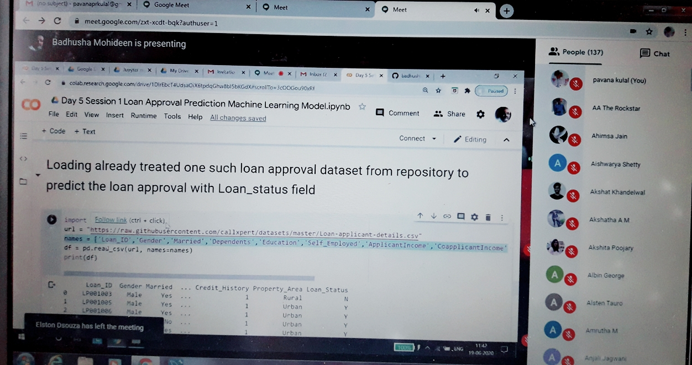

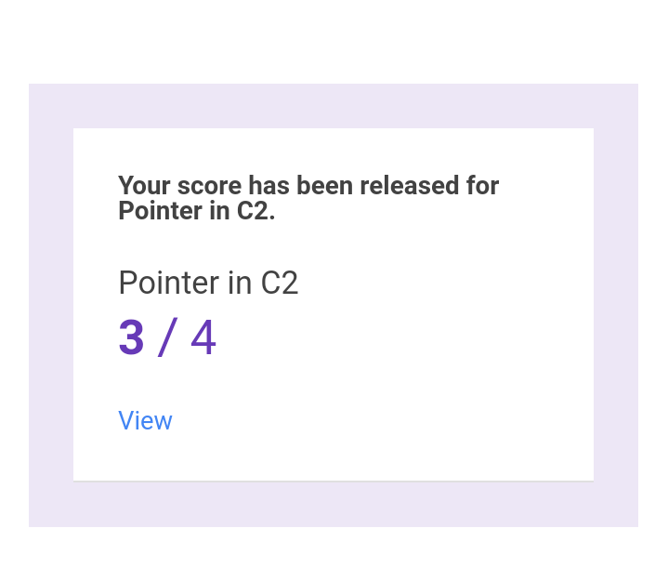

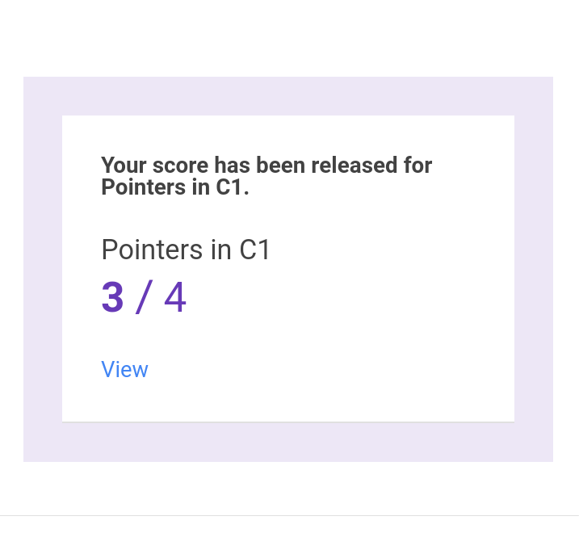

**Workshop Exercise Details:**

<https://github.com/pavana-p-kulal/Applications-of-Python-Programming-in-DA-and-ML>

.**Coding Challenges Details:**

**https://github.com/pavana-p-kulal/DAILY-STATUS/tree/master/19-6-20/Online%20Coding**